About this file
Suggest Edits
The Restaurant Tips Dataset was originally created to study human tipping behaviour in restaurants. It represents real-world data collected by a waiter (or a group of servers) from a restaurant in the United States.
Each row in the dataset corresponds to a single restaurant bill, including the total amount, tip amount, and details about the customer — such as gender, whether they smoke, what day and time they visited, and how many people were in their group.
The goal behind this dataset was to understand:
What factors affect how much people tip.
Whether social or situational factors (like gender, smoking, or time of day) influence tipping.
How group size or total bill amount impacts the percentage of the tip.
Originally, this data was collected for teaching and research purposes in statistics and behavioural economics. It was later included in the Seaborn Python library as one of its example datasets, used widely by students and data scientists to learn data visualization, correlation analysis, and machine learning basics.

Email : Shishupalkumar0926@gmail.com
Contact : 9798679120
Code Links :
1. Basic Insights (Descriptive Statistics)
You can compute:
- Average tip
- Average total bill
- Tip percentage distribution
- Most common visiting day
- Most common visiting time (Lunch vs Dinner)
- Average party size

2. Tip Percentage Analysis
Calculate:
- Tip % = (tip / total_bill) × 100
Then analyze:
- What is the most common tip percentage?
- Do customers tip more during dinner than lunch?
- Are tips higher on weekends?

3. Effect of Customer Gender
You can analyze:
- Do males tip more than females?
- Compare both:
  - Tip amount
  - Tip percentage

4. Smoker vs Non-Smoker Analysis
Explore:
- Do smokers tip more than non-smokers?
- Is the average bill higher for smokers?
- Is tip percentage lower or higher?

5. Day-wise Analysis (Mon–Sun)
You can find:
- Which day has the highest sales?
- Which day receives the highest tips?
- Which day has the highest tip percentage?

6. Time of Day Analysis (Lunch vs Dinner)
Find out:
- Do people spend more during dinner?
- Are dinner tips higher than lunch tips?

7. Group Size Behaviour
Analyze:
- Does a larger group give higher tips?
- Does tip percentage increase or decrease with group size?
Charts you can make:
- Scatter plot → total bill vs tip
- Scatter plot → group size vs tip

8. Correlation Analysis
Use a heatmap to explore relations between:
- total_bill
- tip
- tip_percentage
- size
Questions you can answer:
- Is tip strongly correlated with total bill?
- Does party size affect tip amount?

1. Basic Insights (Descriptive Statistics)
- Average tip = 2.99827868852459
- Average total bill = 19.78594262295082
- Most common visiting day = Saturday
- Most common visiting time (Lunch vs Dinner) = Dinner
- Average party size = 2.569672131147541
2. Tip Percentage Analysis
> Most common tip percentage: 14.482259232440258
> Average tip lunch: 16.412792816250498
> Average tip dinner: 15.951778877977734
> Average tip weekend: 15.95606937940057
> Average tip weekday: 16.330168952923728
> Tips are higher on weekday
3. Effect of Customer Gender
- Average tip male: 15.765054700429742
- Average tip female: 16.649073632892478
- Average tip is female is higher than male
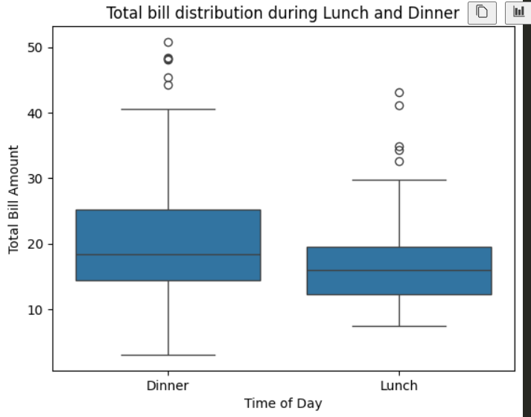

Dinner has higher median or wider range

4. Smoker vs Non-Smoker Analysis
> Average tip smoker: 15.932846217921526
> Average tip non-smoker: 16.319604463687792
> Non-smoker tip more than smoker
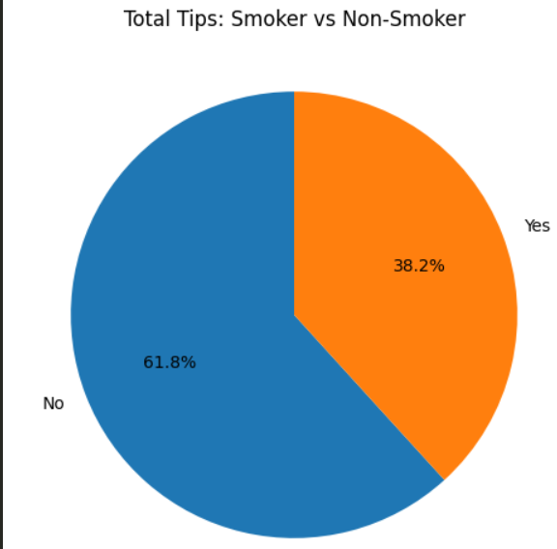
> Non-smoker tip percentage is higher than smoker

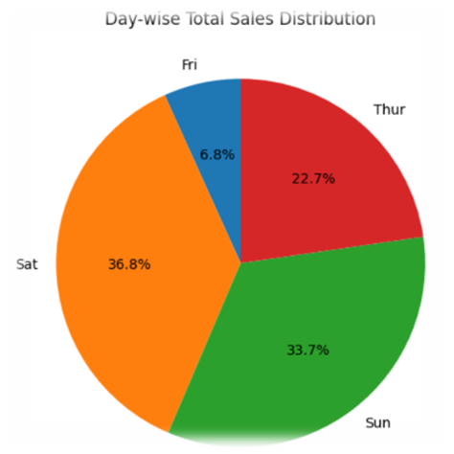
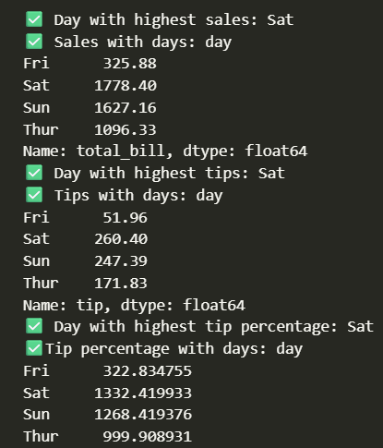
5. Day-wise Analysis (Mon–Sun)
• Which day has the highest sales? Saturday
• Which day receives the highest tips? Saturday
• Which day has the highest tip percentage? Saturday
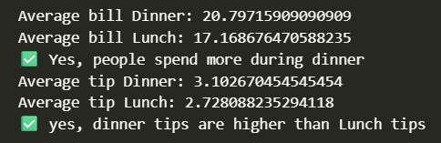
6. Time of Day Analysis (Lunch vs Dinner)
• Do people spend more during dinner? Yes
• Are dinner tips higher than lunch tips? Yes

7. Group Size Behaviour
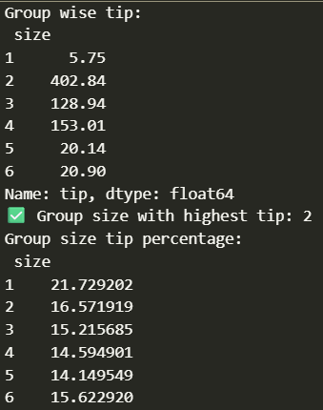
• Does a larger group give higher tips? No
• Does tip percentage increase or decrease with group size? Decrease
Charts you can make:
• Scatter plot → total bill vs tip
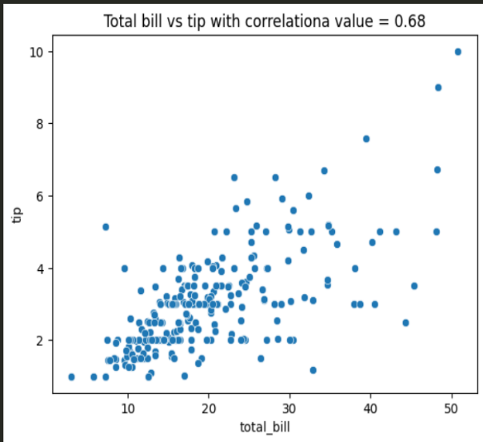
• Scatter plot → group size vs tip
